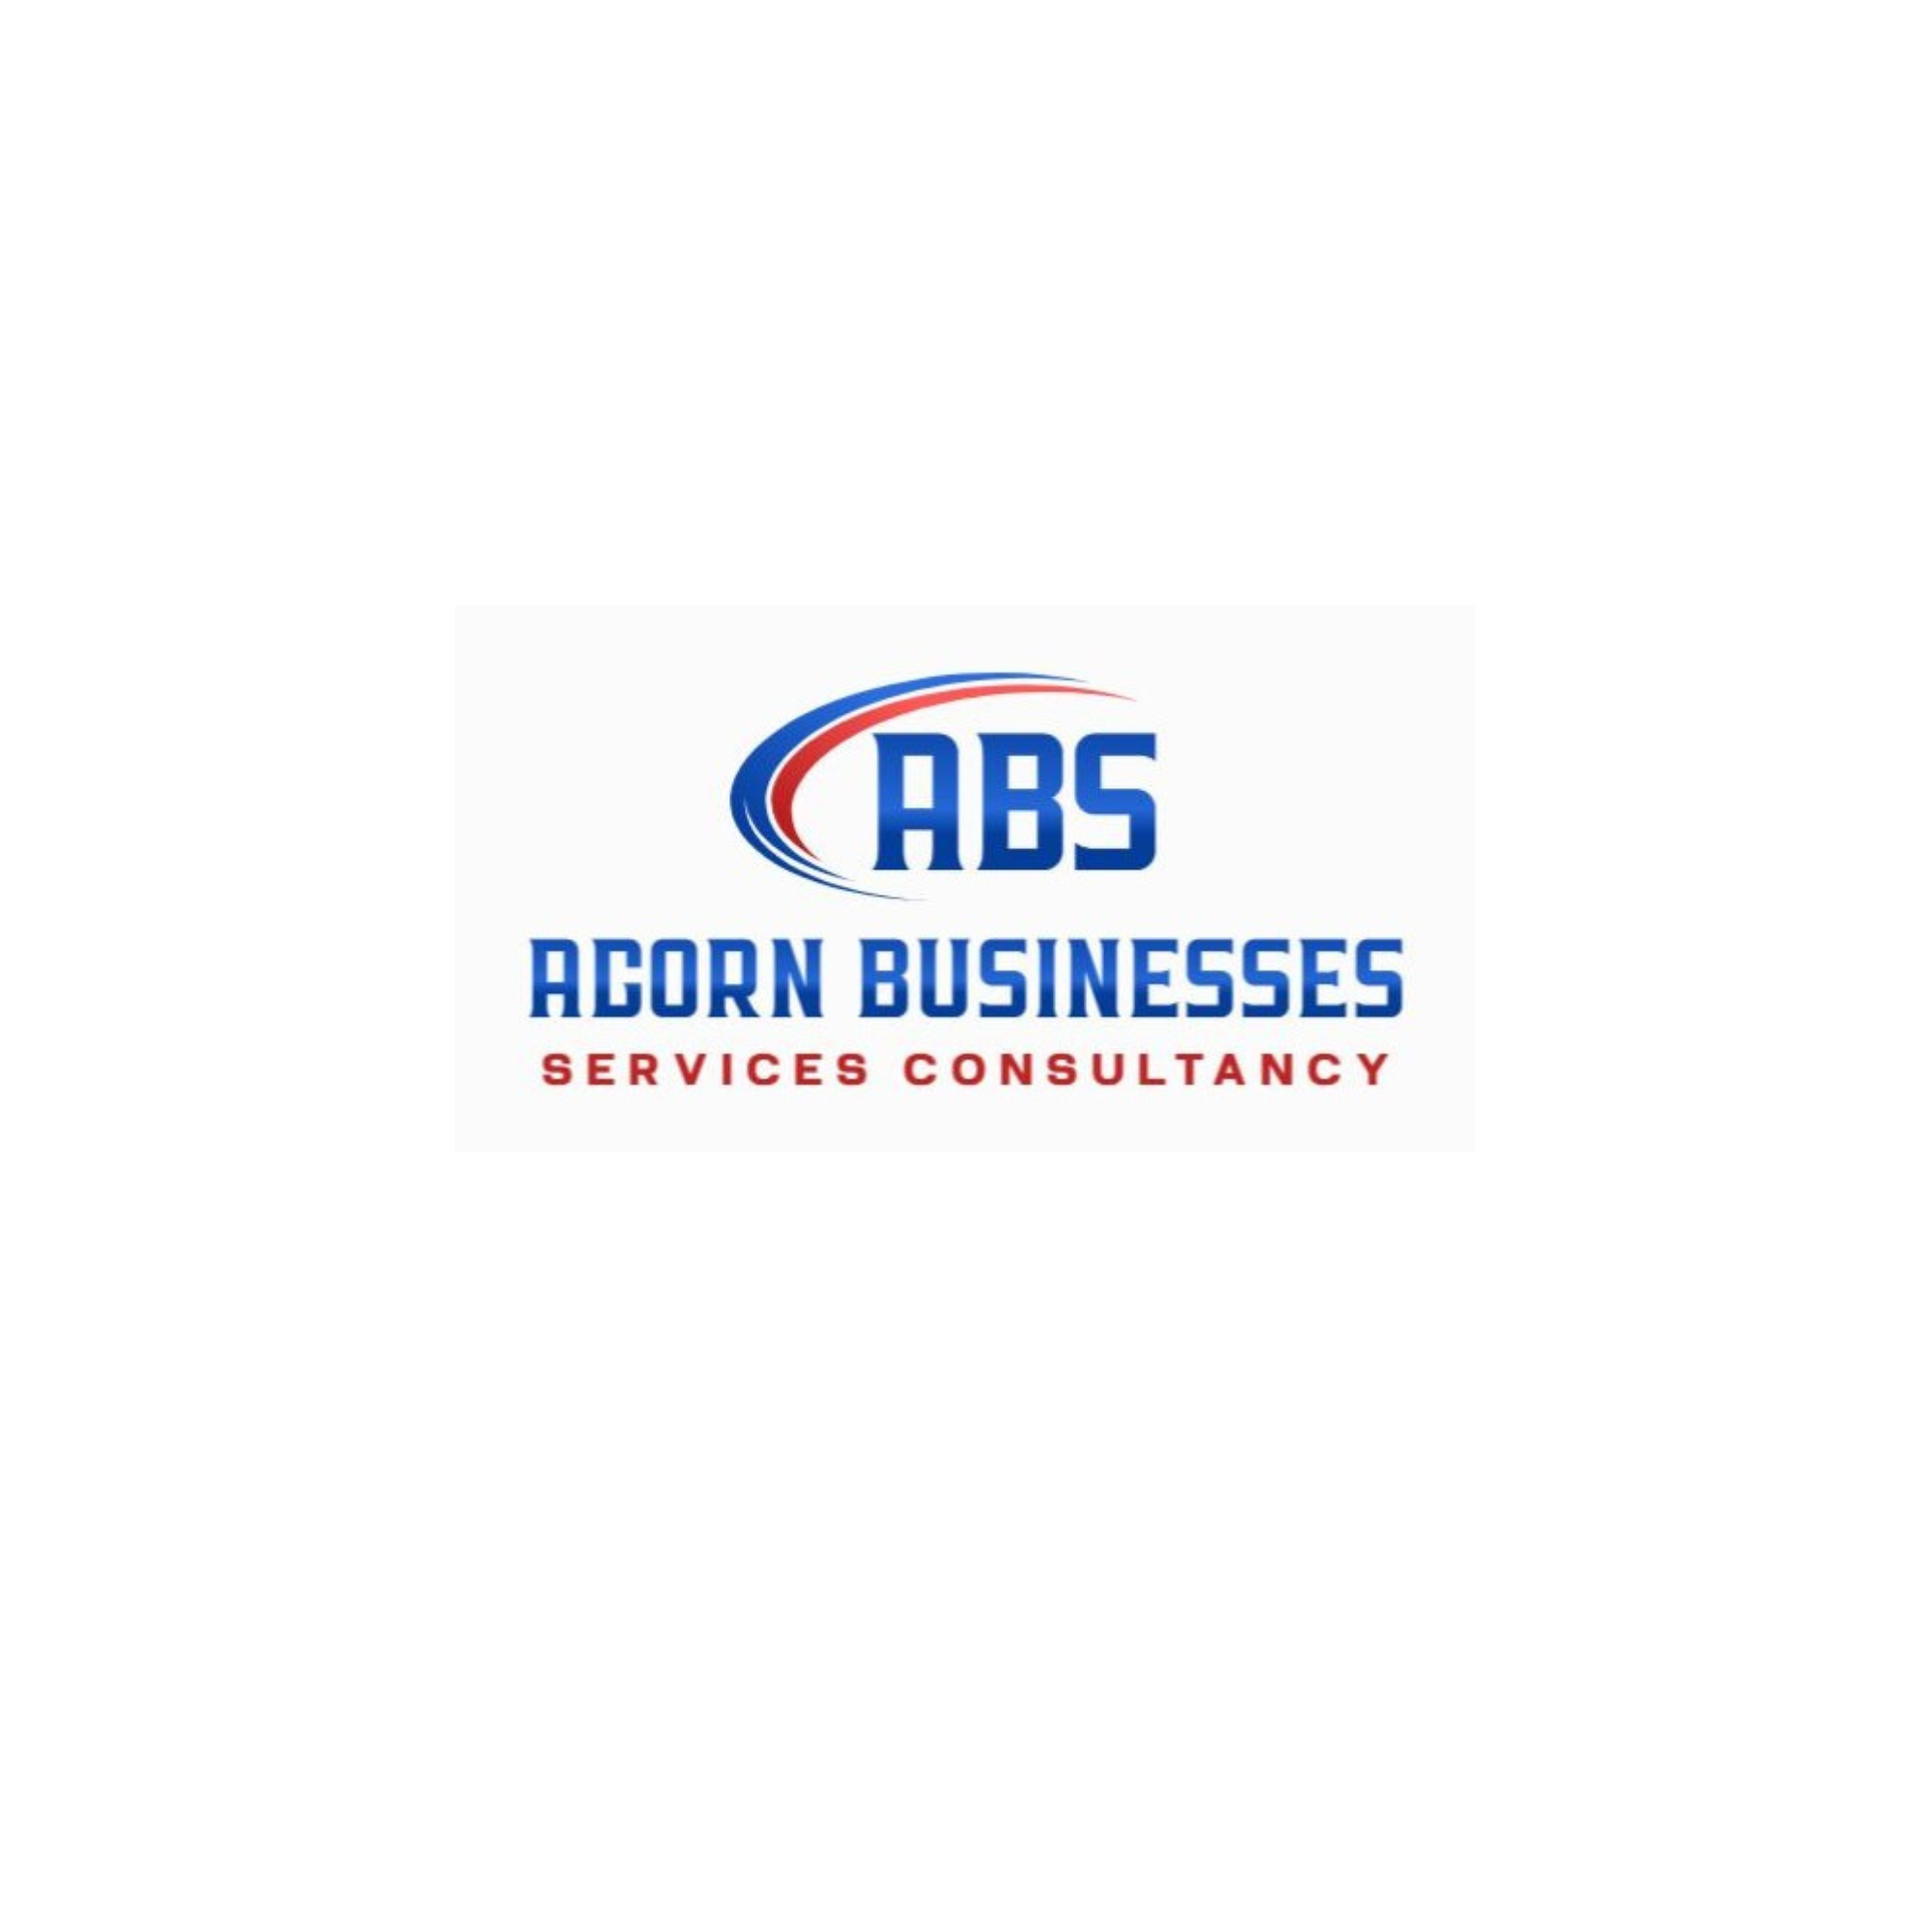
Legal Corporate Advisory Services for Modern Businesses

Running a company involves much more than managing daily operations and generating revenue. Businesses also need to handle contracts. Corporate structures. Regulatory requirements. Tax responsibilities. Employment matters. Compliance obligations. And many other legal concerns. Professional legal corporate advisory services can help businesses understand these responsibilities and make informed decisions while reducing unnecessary legal and commercial risks.
Companies operating across different markets often face increasingly complex regulations. A strong legal advisory approach helps organizations identify potential issues before they become costly problems. With professional guidance from acronhk. Businesses can receive practical support for corporate matters and develop strategies that align with their operational and commercial goals.

What Are Legal Corporate Advisory Services?
Legal corporate advisory services provide businesses with professional legal guidance related to corporate activities. These services can support companies during formation. Expansion. Restructuring. Transactions. Contract negotiations. Compliance planning. And other important business decisions.

Corporate legal advisors help management teams understand how laws and regulations may affect their business activities. Instead of addressing legal problems only after they appear. Companies can use advisory support as part of their regular decision-making process.
Depending on business requirements. Corporate advisory support may cover areas such as:
- Company formation and corporate structuring.
- Contract preparation and review.
- Corporate governance.
- Regulatory compliance.
- Mergers and acquisitions.
- Business restructuring.
- Shareholder agreements.
- Commercial transactions.
- Employment-related corporate matters.
- Tax-related legal considerations.
- Risk management and legal planning.
The right advisory strategy depends on the company's industry. Size. Structure. Location. And long-term objectives.

Importance of Advisory Services for Corporate Businesses
Modern organizations regularly make decisions that can have legal and financial consequences. Professional advisory services for corporate businesses can provide management teams with the information needed to evaluate these decisions carefully.
For example. A company entering a new market may need to understand local regulations. A business signing a major commercial agreement may need a detailed contract review. A company planning a restructuring may need guidance regarding corporate procedures and stakeholder rights.
Working with acronhk can help businesses approach these matters with greater clarity and structured planning.

Important benefits can include:
- Better risk identification: Legal advisors can help identify potential risks before important decisions are finalized.
- Improved compliance: Businesses can better understand applicable corporate and regulatory requirements.
- Stronger contracts: Professional review can help companies understand important contractual terms and obligations.
- Business planning support: Legal considerations can be included in broader commercial strategies.
- Efficient decision-making: Management can make decisions with a clearer understanding of potential legal implications.
- Long-term protection: Proactive legal planning can help reduce avoidable disputes and compliance problems.

Corporate Legal Advisory Services Comparison by Industry

The requirements for corporate legal support can differ significantly from one industry to another. A technology company may face different contractual and regulatory concerns than a manufacturing company. A financial services organization may have more extensive compliance requirements than a retail business.
This makes corporate legal advisory services comparison by industry an important consideration when selecting professional support.
For example:

Technology and Digital Businesses
Technology companies may require advice relating to software agreements. Intellectual property. Data protection. Technology contracts. Licensing. And commercial partnerships.

Manufacturing Companies
Manufacturing businesses may need support with supplier contracts. Distribution agreements. Corporate structures. Employment matters. Regulatory obligations. And commercial transactions.

Financial Services
Financial businesses often operate in highly regulated environments. Their advisory requirements may include corporate governance. Regulatory compliance. Transaction structures. And risk management.

Retail and Consumer Businesses
Retail companies may require assistance with commercial contracts. Supplier relationships. Employment issues. Customer-related obligations. And business expansion.

Professional Services
Consulting firms. Agencies. And other professional businesses can benefit from contract review. Corporate structuring. Partnership arrangements. And regulatory guidance.
Understanding these differences helps companies select advisory services that match their specific operational environment.

Corporate Tax and Legal Planning
Tax obligations are another important consideration for companies. Businesses may need to understand how corporate structures. Transactions. Investments. And business activities can affect their tax responsibilities.
The corporate tax law advisory services market has become increasingly relevant as businesses seek professional guidance regarding changing tax rules and regulatory expectations. Companies operating internationally may face additional considerations because different jurisdictions can have different tax systems and compliance requirements.
Professional corporate advisory support can help businesses evaluate the legal aspects of tax-related decisions. This may involve reviewing corporate structures. Understanding applicable obligations. Assessing transactions. And coordinating legal considerations with broader business planning.

Businesses should always obtain advice that is appropriate to their specific circumstances. Tax rules can vary based on jurisdiction and individual business structures.

How acronhk Supports Corporate Businesses
acronhk provides corporate and business advisory support designed to help organizations address important legal and commercial considerations. Businesses can benefit from structured guidance when dealing with corporate documentation. Transactions. Governance. Compliance. And other business matters.
A professional advisory relationship can also provide businesses with a more organized approach to managing legal responsibilities.
Key areas of support may include:
- Corporate structuring guidance.
- Company formation assistance.
- Contract and agreement review.
- Corporate compliance support.
- Business transaction guidance.
- Corporate governance assistance.
- Tax-related corporate advisory considerations.
- Strategic legal planning.
- Risk assessment.
- Ongoing corporate support.
The objective is not simply to solve individual legal issues. It is to help businesses develop a stronger approach to managing corporate responsibilities.

Why Businesses Need Proactive Legal Advice

Many companies seek legal assistance only when they encounter a dispute or regulatory problem. However. A proactive approach can be more effective because potential issues can be identified earlier.
For example. Reviewing a contract before signing it may help a company understand unfavorable obligations. Reviewing a corporate structure before expansion may help management identify possible regulatory requirements. Similarly. Regular compliance reviews can help businesses remain aware of their responsibilities.
This is why legal corporate advisory services can be an important part of long-term business planning.
Proactive advice can help organizations:
- Identify potential legal exposure.
- Understand contractual obligations.
- Improve corporate governance.
- Prepare for business expansion.
- Manage regulatory responsibilities.
- Support strategic transactions.
- Reduce avoidable business risks.

Choosing the Right Corporate Advisory Provider
Selecting a suitable corporate advisor requires careful consideration. Businesses should evaluate whether the provider understands their industry. Business model. Corporate structure. And commercial objectives.
Companies may consider the following factors:
- Relevant corporate advisory experience.
- Understanding of applicable regulations.
- Industry knowledge.
- Quality of communication.
- Range of services.
- Practical approach to legal problems.
- Ability to support long-term business requirements.
- Understanding of local and international business environments.
A suitable provider should be able to explain complex legal matters in a clear and practical manner. This allows business owners and management teams to make better-informed decisions.

Conclusion
Professional legal corporate advisory services can play an important role in helping businesses manage legal responsibilities and commercial risks. From corporate formation and governance to contracts. Compliance. Transactions. And tax-related considerations. Businesses regularly face decisions where professional guidance can add significant value.
The growing importance of advisory services for corporate organizations also highlights the need for specialized and practical support. At the same time. corporate legal advisory services comparison by industry shows why businesses should choose solutions that match their specific sector and operational requirements. The development of the corporate tax law advisory services market further demonstrates the importance of informed planning around corporate and tax-related matters.
With the support of acronhk. Businesses can approach corporate legal and advisory matters with greater structure. Clarity. And confidence. A proactive advisory strategy can help organizations manage risks. Understand their responsibilities. And build a stronger foundation for sustainable business growth.

Contact details

Name : ACORN BUSINESSES SERVICES AND CONSULTANCY LIMITED

Email : info@acornhk.com

Address : Room 2002, 20/F, Hing Yip Commercial Centre,272-284 Des Voeux Road Central

Website : https://www.acornhk.com

